**53.4. Spring Security - Display Content based on Roles**

**Display Content Based on Roles**:

Now we display content based on roles. In our home page after login, for all user we see the link of "[LeaderShip Meeting](http://localhost:8080/spring-security-demo/leaders)" and "[IT Systems Meeting](http://localhost:8080/spring-security-demo/systems)" which is for "MANAGER" and "ADMIN" roles respectively. But we see them for "EMPLOYEE" role also. Let fixed it.

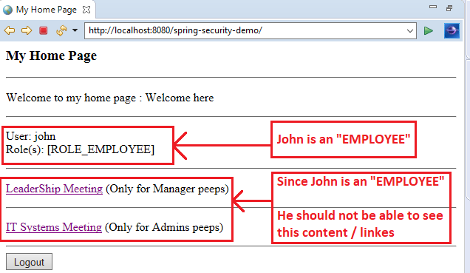

Now for fixed it, we have to modify our "**home.jsp**" page and add some code.

**Development process (Step-by-Step)**:

1. Add security tags (We already add the Spring-security taglib)
2. Display "MANAGER" related content for only "MANAGER" role.
3. Display "ADMIN" related content for only "ADMIN" role.

**Step-1: Add security tag (We already add the Spring-security taglib)**:

<%@ taglib prefix=*"security"*

uri=*"http://www.springframework.org/security/tags"*%>

**Step-2: Display "MANAGER" related content for only "MANAGER" role**:

<security:authorize access=*"hasRole('MANAGER')"*>

<p>

<!-- Add a link to point to /leaders ... this is for the managers -->

<a href=*"*${pageContext.request.contextPath}*/leaders"* >LeaderShip Meeting</a>(Only for Manager peeps)

</p>

</security:authorize>

**Step-3: Display "ADMIN" related content for only "ADMIN" role**:

<security:authorize access=*"hasRole('ADMIN')"*>

<p>

<!-- Add a link to point to /systems ... this is for the admins -->

<a href=*"*${pageContext.request.contextPath}*/systems"* >IT Systems Meeting</a> (Only for Admins peeps)

</p>

</security:authorize>

**Now test our App**:

**John have "EMPLOYEE" roles**:

Here "John" is an "EMPLOYEE" he cannot see content/links based on his roles.

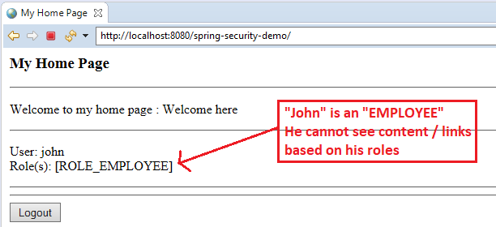

**Mary have "EMPLOYEE" and "MANAGER" roles**:

Here "mary" is an "EMPLOYEE" and also a "MANAGER". he can see "MANAGER" related content/links based on his roles.

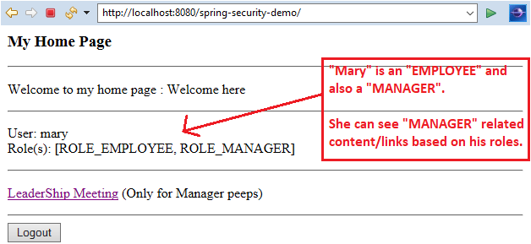

**Susan have "EMPLOYEE" and "ADMIN" roles**:

Here "Susan" is an "EMPLOYEE" and also an "ADMIN". He can see "ADMIN" related content/links based on his roles.

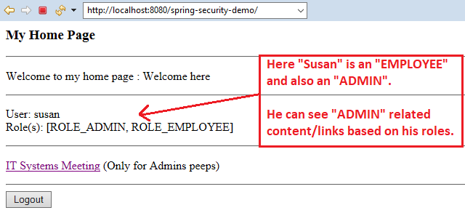

53.4. Spring Security - Display Content based on Roles